**The Ark Documentation.**

**Work Request**

Log in and select your study by clicking the hyperlink corresponding to the name of your study.

Once you have chosen your study we will be able to adjust study details or select modules and functions available in that study (for which you have privileges).

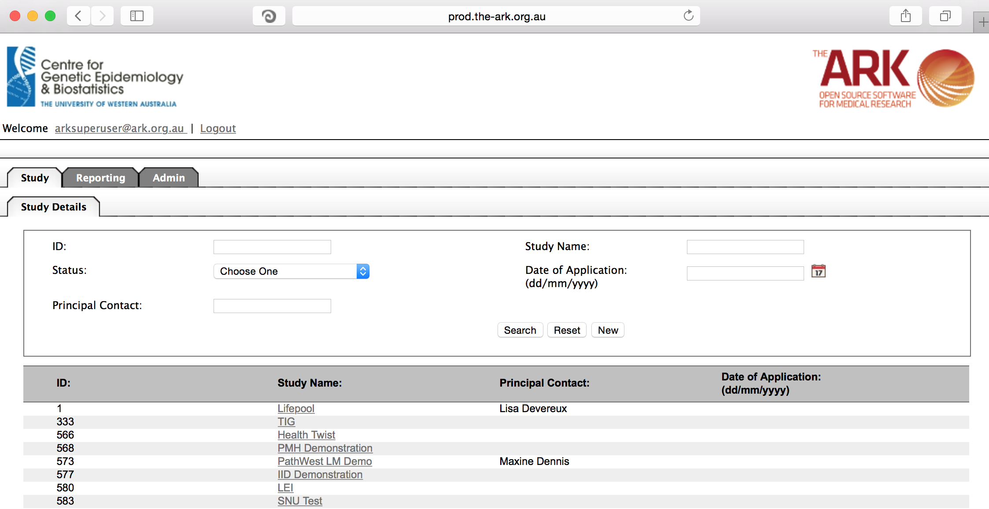

Alternatively if you have a very long list of studies under your management you may use the search pallette/panel at the top of the page. You can search/filter by id, name, principal contact, status of the study or date of application. Once you have added your filtering criteria, click the search button;

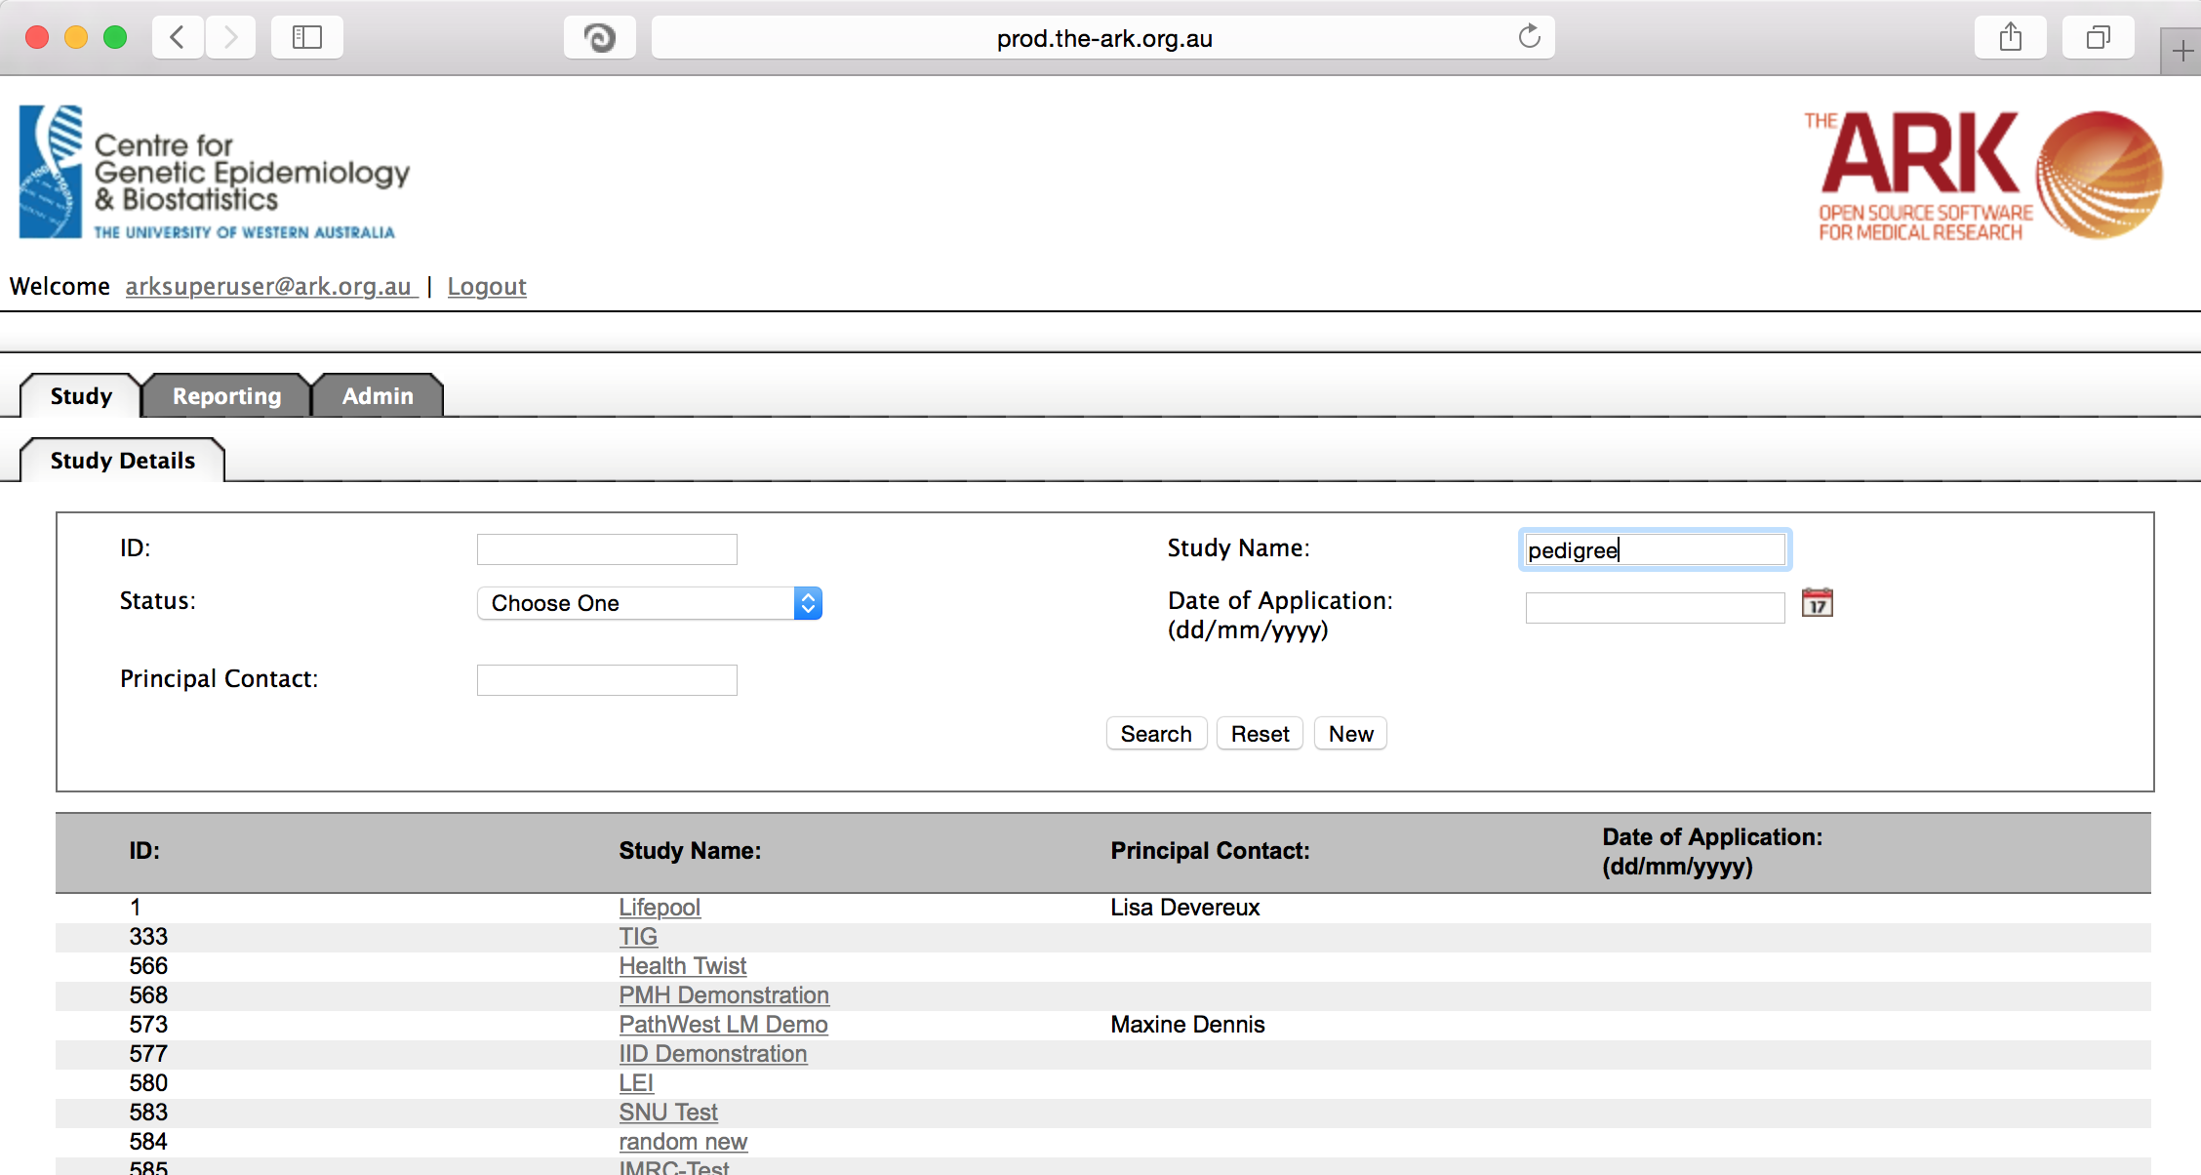

As you can see the filter has helped us find our chosen study and we can click the hyperlinked study name as discussed before;

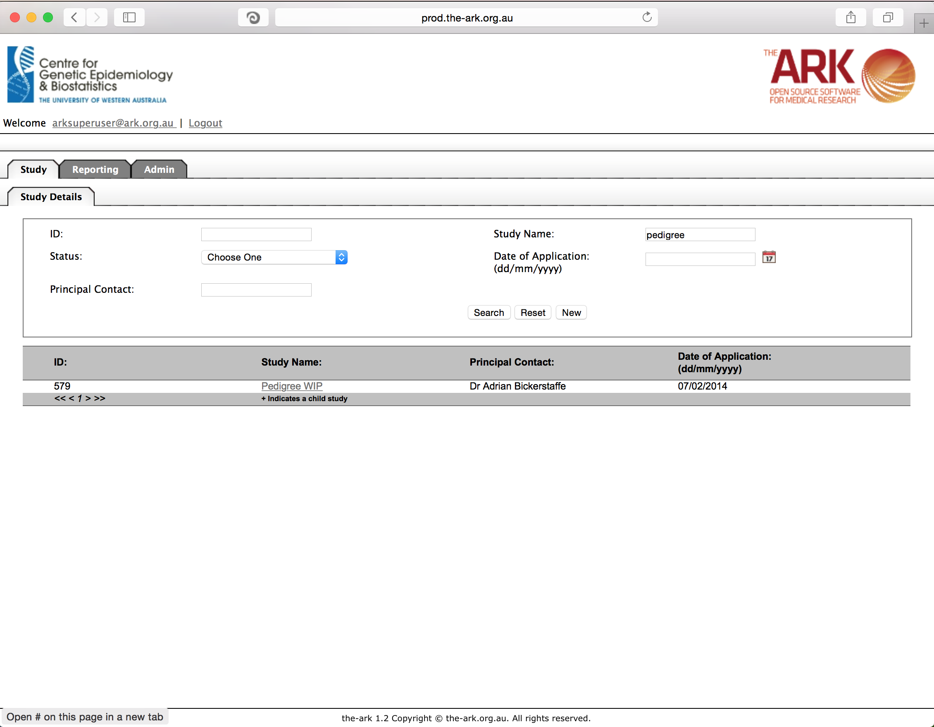

Once you have chosen your study we will be able to adjust study details or select modules and functions available in that study (for which you have privileges). The module we wish to select is Work Tracking – Billable Item Type.

Work Tracking module is created with the intention of allowing collaborating researchers to log work and charges (billable items) to studies/researchers.

This simple page is for controlling the list of available billable items (another way to think of them is reusable tasks with which you can associate a cost of charge to a project). As you can see the same standard lay out of a list and filterable fields starts us off. You can see we have 3 billable items listed so far.

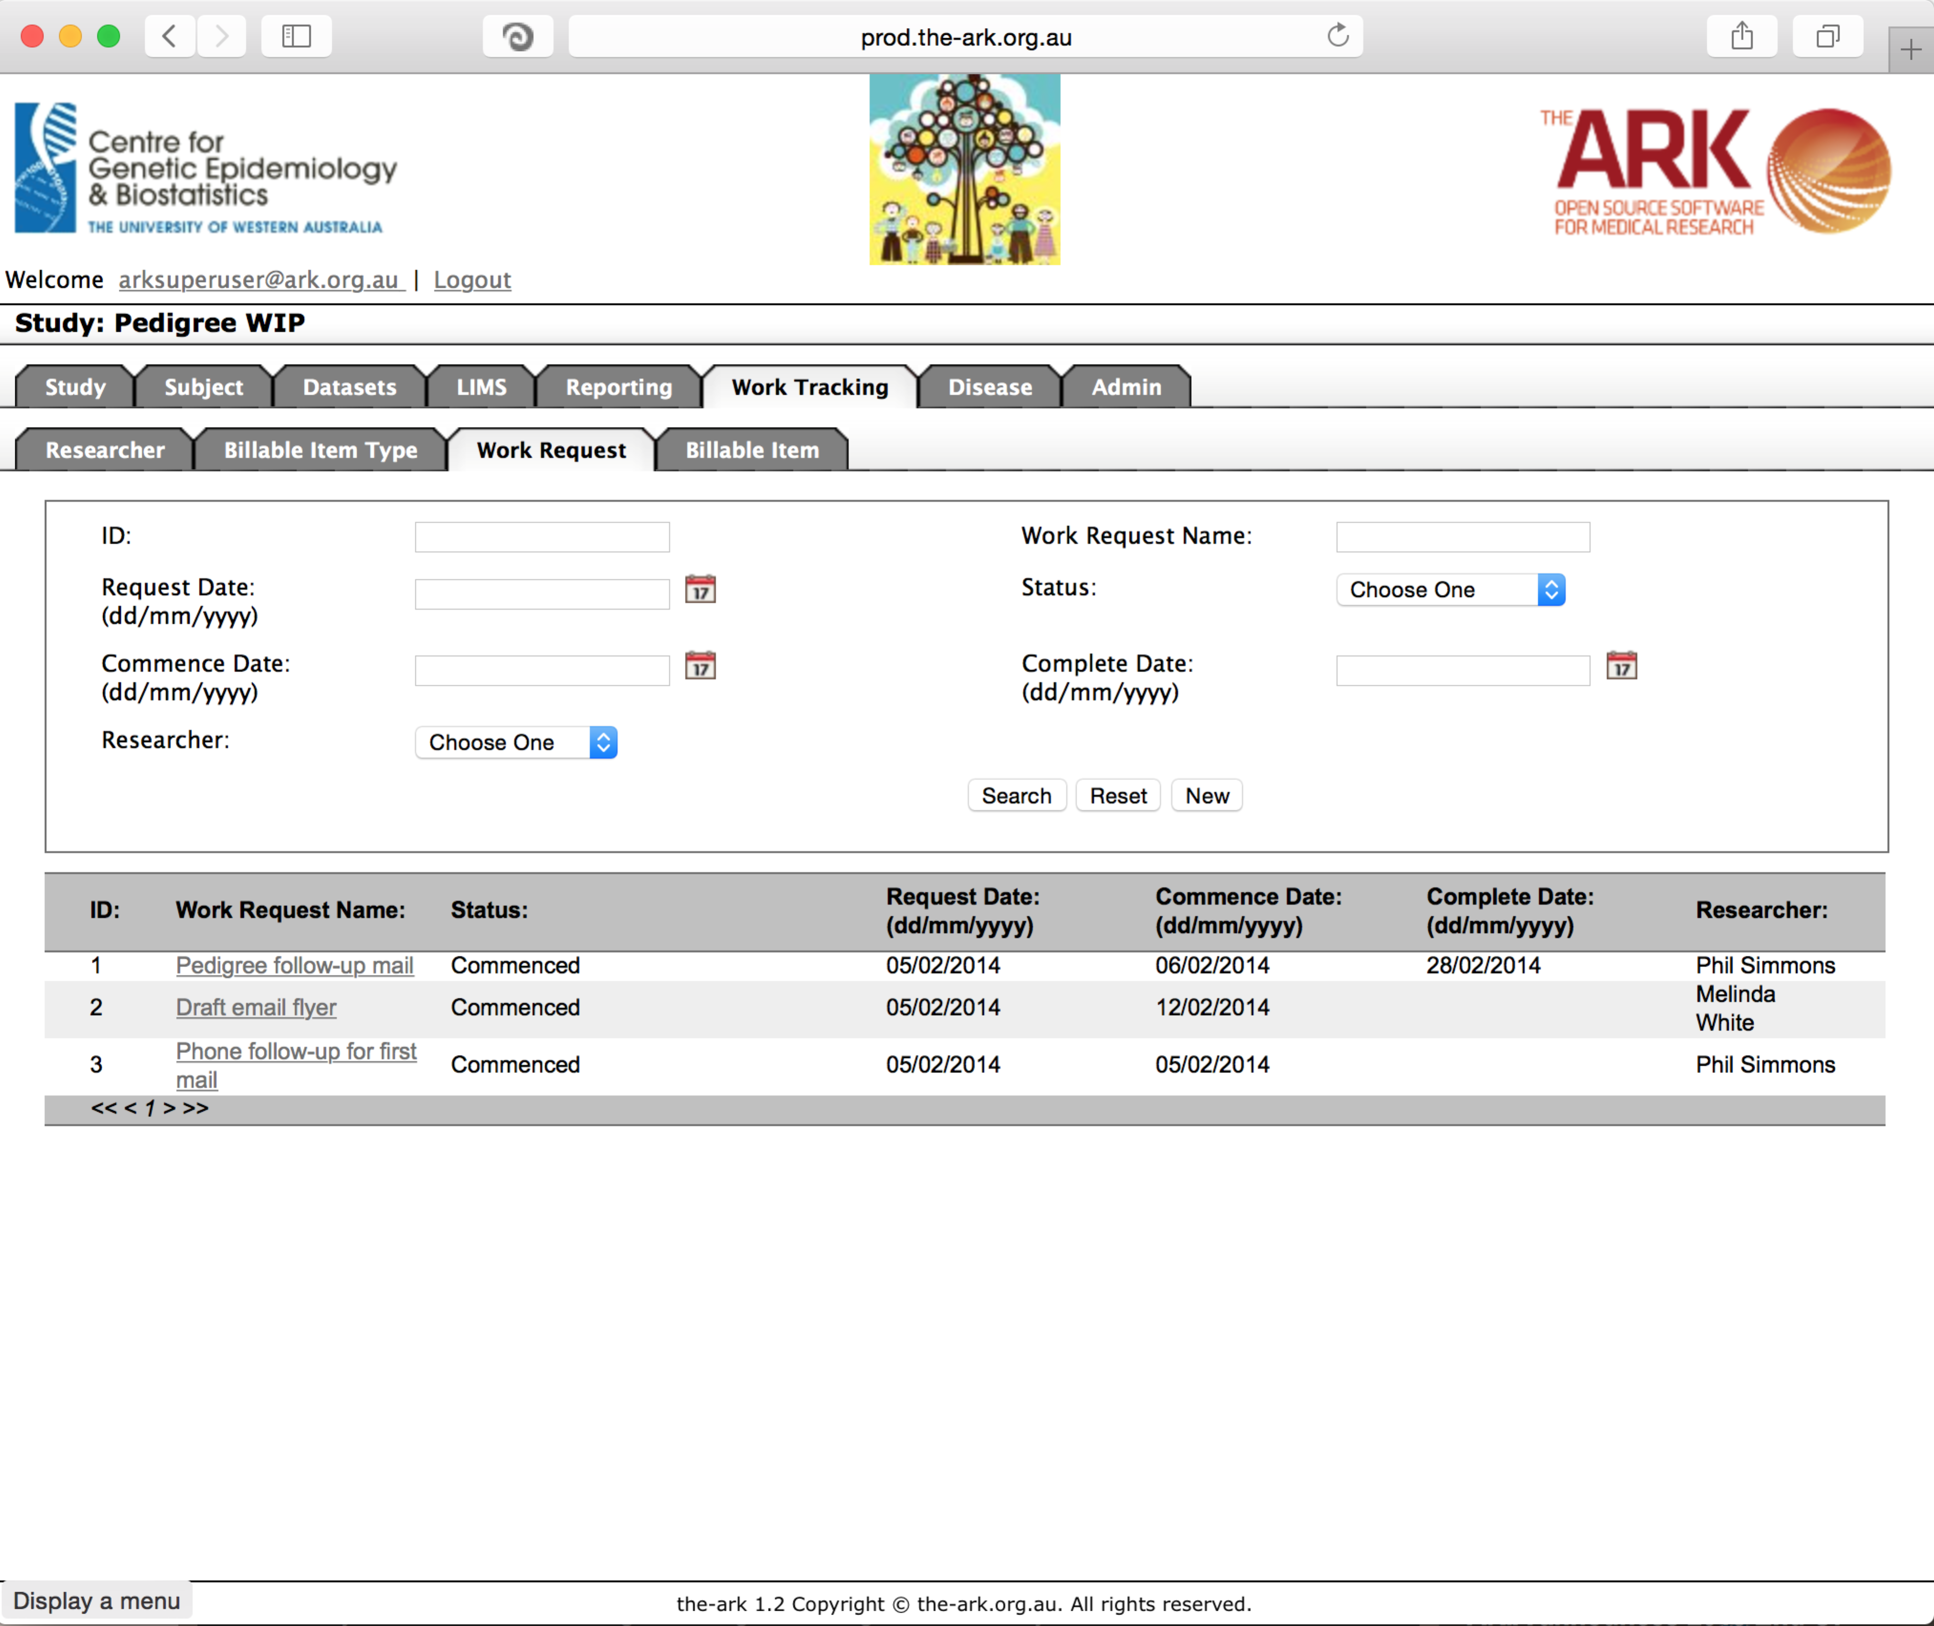

We will now add a 4th type of billable item.

Start by clicking the new button. The following will appear;

The fields are all self-explanatory. The only note is that any field with a “*” is required/compulsory.

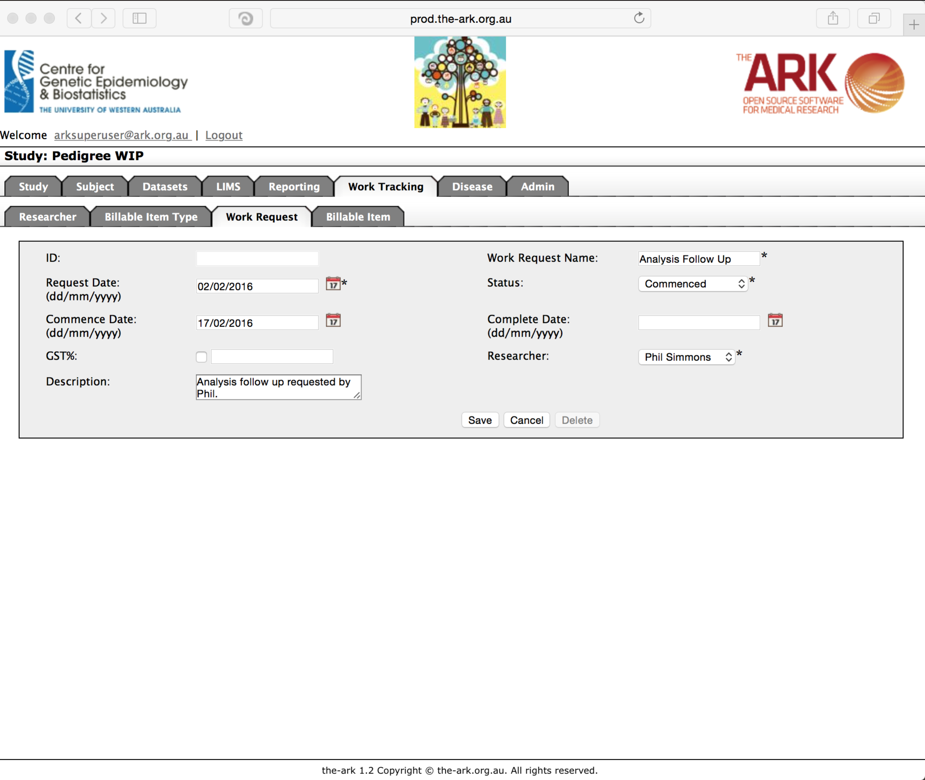

Then click save;

If you have no issues and it has correctly saved, the you will have a green message at the top of the page telling you so. If there were any issues (rare on this page), a message will show up in red describing what you have done wrong.

